Title Times New Roman 14, Times New Roman 14, Times New Roman 14, Times New Roman 14, Times New Roman 14
Name Last Name¹ Times New Roman 10 , Name Last Name² Times New Roman 10
¹Affiliation, City, State, Times New Roman 10
²Affiliation, City, State, Times New Roman 10

Corresponding author’s email xxxx@gmail.com
Abstract: Times New Roman 12, Times New Roman 12, Times New Roman 12, Times New Roman 12, Times New Roman 12, Times New Roman 12, Times New Roman 12, Times New Roman 12, Times New Roman 12, Times New Roman 12, Times New Roman 12, Times New Roman 12, Times New Roman 12, Times New Roman 12, Times New Roman 12, Times New Roman 12, Times New Roman 12, Times New Roman 12, Times New Roman 12, Times New Roman 12, Times New Roman 12, Times New Roman 12
Keywords: Times New Roman 10, Times New Roman 10, Times New Roman 10, Times New Roman 10, Times New Roman 10

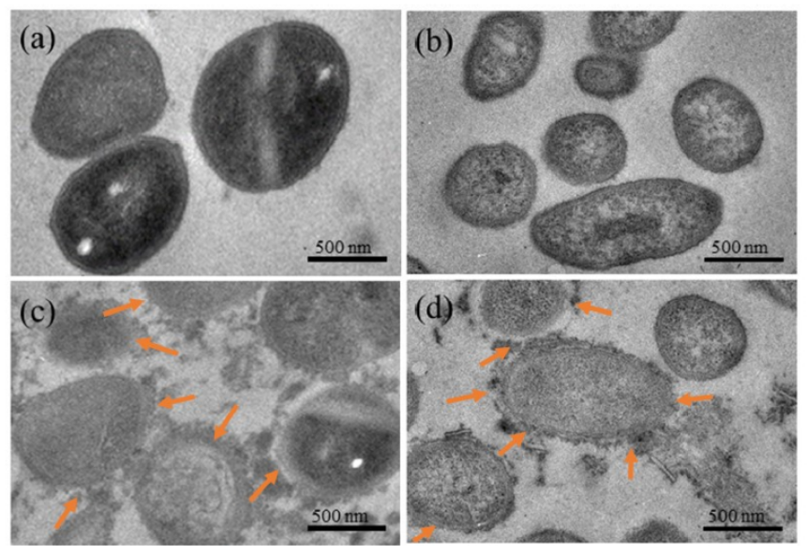
Figure: The caption of the fìgures
Short biograpgy <corresponding author>:

